## UNIVERSITY OF BERN

## MASTER OF SCIENCE ARTIFICIAL INTELLIGENCE IN MEDICINE

**One-page Summaries Style Sheet**

*Software*

* Use **Microsoft Word** only for the one-page summary, never Open Office.
* Students can download **free** Office programs in the UniBe software shop <http://www.unibe.ch/university/campus_and_infrastructure/rund_um_computer/soft_und_hardware/software/index_eng.html>

*Photo*

* Delete the photo in the template
* Replace the appearing text with your photo
* The photo should be aligned with the upper and lower margins of the header and the right text margin. Approximate size: 3,6 x 2,7 cm (4:3), passport style.
* 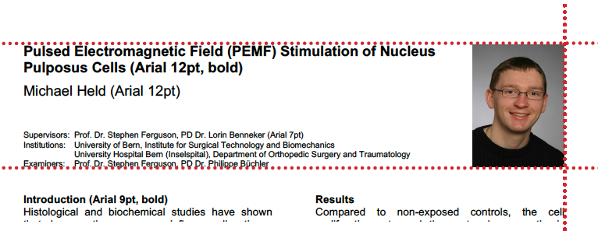**You decide what you look like!**

*Supervisors*

*Titles*

Swiss style (German)

Prof. Dr. / PD Dr. / Dr. / Dr. med. / Dr. med. dent.

Examples:

Prof. Dr. Raphael Sznitman

Enumerations of two or more people: use comma, don’t use “and”.

Example:

Prof. Dr. Volker M. Koch, Prof. Dr. Marcel Jacomet

*Institutions*

English

University of Bern

University Hospital Bern (Inselspital)

All Swiss universities have a correct English translation. Look it up, don’t make one up!

*Institutes / Departments (Inselspital)*

ARTORG Center for Biomedical Engineering Research

Department of Neurosurgery (example)

Don’t mention the research group!

Example:

University of Bern, ARTORG Center for Biomedical Engineering Research

~~Medical Image Analysis~~

University Hospital Bern (Inselspital), Department of Cardiology

## Michael Held.jpgPulsed Electromagnetic Field (PEMF) Stimulation of Nucleus Pulposus Cells (Arial 12pt, bold)

Replace this text with a portrait photo approx. 2.7x3.5cm

You decide what you look like!

Michael Held (Arial 12pt)

Supervisor(s): Prof. Dr. Stephen Ferguson, PD Dr. Lorin Benneker (Arial 7pt)

Institution(s): University of Bern, ARTORG Center for Biomedical Engineering Research

University Hospital Bern (Inselspital), Department of Orthopedic Surgery and Traumatology

**Introduction (Arial 9pt, bold)**

Histological and biochemical studies have shown that degenerative processes influence disc tissue structure, composition and cellular activity. Current surgical treatments for disc degeneration do not preserve normal disc function, therefore it is desirable to develop alternative treatments to slow or even reverse the degenerative process. Minimally-invasive therapy with pulsed electromagnetic ﬁelds (PEMF), as applied already for articular cartilage, may have promise. The aim of this study was to determine the influence of PEMFs on nucleus pulposus (NP) cell proliferation and the synthesis of disc-speciﬁc proteins (Arial 9pt).

**Materials and Methods**

Three monolayer (2D) experiments and two 3D experiments were conducted. Bovine coccygeal NP cells were isolated and cultured directly as 2D monolayers in 6-well plates, or encapsulated first in 3D agarose beads, and exposed to PEMF for up to 14 days, with an exposure interval of 18 h per day. PEMF fields were generated within custom-built chambers employing active and passive coils. The EMF pulses had a duration of approximately 1.2 ms, a ﬂux density of 1.5 mT, and a repetition rate of 2 and 75 Hz, respectively. Field characteristics were verified by simulation (COMSOL).

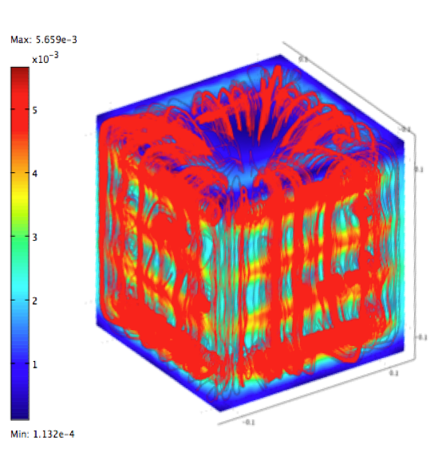

Fig. 1 COMSOL simulations demonstrated uniform field characteristics within the chamber volume (Arial, 8pt, italic). (You must have authorization to publish this image)

Outcome measures included cell viability, proliferation, proteoglycan production and the expression of anabolic genes, evaluated via qRT-PCR.

**Results**

Compared to non-exposed controls, the cell proliferation rate and the proteoglycan synthesis increased (+26.1% and +20.4%, respectively) for NP cells exposed to appropriate pulsed electromagnetic ﬁelds. No conclusive trends could be identified in gene expression profiles.

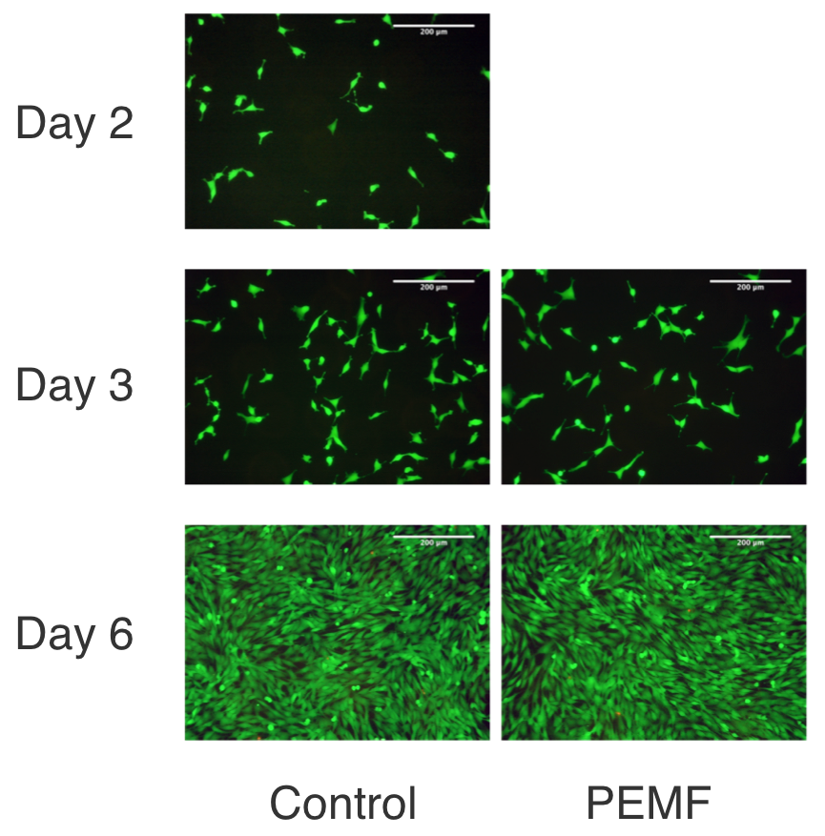

Fig. 2 Nucleus pulposus cells cultured in monolayer and stimulated with 2.3 mT, 2 Hz pulse frequency showed a high cell viability (Arial, 8pt, italic). (You must have authorization to publish this image)

**Discussion**

These results correspond to the findings of similar studies performed on chondrocytes, although the magnitude of the effect observed in the present study was substantially lower. PEMF field exposure induced a predominantly mitogenic effect in the NP cells. While the application of PEMF remains an attractive possibility for the non-invasive treatment of disc disorders, the effective field strength and high level of field control required should be critically evaluated.

**References**

Chevalier Y. and Charlebois M., The role of fabric in large strain compression of trabecular bone, Biomechanics and Modeling in Mechanobiology 12(3): 43-52, 2009.

**Acknowledgements**

The project was supported by grant no XYZ of the Swiss national science foundation (SNF) and the Commission for Technology and Innovation CTI. The important contribution of Urs Rohrer for construction of the experimental set-up is gratefully acknowledged.